**.FINAL PROJECT DESCRIPTION FOR PRN232 COURSE**

**SUMMER2025**

**Cruise Ticket Booking System**

**Group11**

**Table of contents**

**Information of members**

| **No** | **Fullname** | **Absent rate** |
| --- | --- | --- |
| HE176204 | Đinh Quang Khương |  |
| HE176153 | Nguyễn Tống Sơn Trà |  |
| HE173548 | Trịnh Xuân Thái |  |
| HE176423 | Hoàng Việt Dũng |  |
|  |  |  |

**Plan for Project (9 weeks)**

| **No** | **Task** | **Member** | **Time** |
| --- | --- | --- | --- |
| 01 | Create team/Group |  | Week 1- slot 1 |
| 02 | Choose topic final project |  | Week 1- slot 2 |
| 03 | Project Description |  | Week 2 – slot 3 |
| 3.1 | Introduction |  | Week 2 – slot 4 |
| 4 | Requirement Analysis |  | Week 3 – slot 5 |
| 5 | High-level System Design |  | Week 3 – slot 6 |
| 6 | Use Case Diagrams & Data Modeling |  | Week 4 – slot 7 |
| 7 | UI/UX Design |  | Week 4 – slot 8 |
| 8 | Database Schema & Backend Setup |  | Week 5 – slot 9 |
| 9 | Implement Core Features - Part 1 |  | Week 5 – slot 10 |
| 9.1 | Implement Core Features - Part 2 |  | Week 6 – slot 11 |
| 10 | Mid Project Review & Integration |  | Week 6 – slot 12 |
| 11 | Advanced Features & Optimization |  | Week 7 – slot 13 |
| 12 | Frontend Polishing & Validation |  | Week 7 – slot 14 |
| 13 | Report Writing - Part 1 |  | Week 8 – slot 15 |
| 14 | Final Testing |  | Week 8 – slot 16 |
| 15 | Report Writing - Part 2 |  | Week 9 – slot 17 |
| 16 | Submit report, project |  | Week 9 – slot 18 |

# I. Introduction

The cruise industry represents a significant sector within the global tourism market, offering travelers unique experiences and exotic destinations. However, traditional cruise ticket booking systems often present numerous challenges for both customers and cruise operators. As the demand for cruise travel continues to grow, there is an increasing need for more efficient, user-friendly booking solutions. Customers frequently experience extended waiting periods when booking tickets through traditional channels, particularly during peak seasons or promotional periods. Conventional booking methods are often restricted to specific locations and business hours, limiting customers' ability to make reservations at their convenience. Travelers struggle to access up-to-date information about cruise schedules, cabin availability, pricing, and onboard amenities. Current payment systems may be limited in their options and often involve cumbersome processes that decrease customer satisfaction. Paper tickets are susceptible to loss or damage, creating challenges for both passengers and administrative staff. Existing systems frequently fail to accommodate special requests or personalized experiences that modern travelers expect. Cruise operators face challenges in collecting, organizing, and analyzing customer data to improve services and optimize operations. Traditional systems may lack robust security measures, making them vulnerable to fraud and unauthorized access. Many current booking systems operate in isolation, without proper integration with other essential services such as shore excursions, dining reservations, or onboard activities. Existing platforms often provide limited customer service options, particularly for post-booking inquiries or changes. The proposed Cruise Ticket Booking System aims to address these challenges by implementing a comprehensive, secure, and user-friendly online platform. This system will enhance the booking experience for customers while providing cruise operators with powerful tools for managing reservations, analyzing trends, and delivering exceptional service.

1. Administrator:

- Manage the entire system configuration and operation

- Create and modify cruise routes, schedules, and pricing

- Monitor booking activities and generate comprehensive reports

- Manage staff accounts and assign appropriate access privileges

- Access and analyze business performance metrics

- Configure promotional campaigns and discount policies

- Manage integration with payment gateways and other external services

2. Staff Member:

- Process booking requests and manage reservations

- Assist customers with the booking process

- Handle customer inquiries and provide necessary information

- Make changes to existing bookings as requested by customers

- Process cancellations and refund requests according to company policy

- Verify customer identities and booking details

- Generate booking confirmations and tickets

- Manage cabin inventory and availability updates

- Document customer interactions and special requests

- Address booking-related issues and escalate when necessary

3. Customer:

- Register and manage personal account information

- Search and browse available cruises, routes, and schedules

- View cabin types, amenities, and real-time pricing

- Make cruise reservations and select preferred accommodations

- Submit special requests and preferences for their journey

- Process payments securely through various payment methods

- Access and download electronic tickets and boarding passes

- View booking history and current reservation status

- Modify or cancel bookings within the specified policy guidelines

- Submit feedback about cruise services and booking experience

# II. Project Objectives

In this project, Group …. will:

# III. Database Design

# 3.1 ERD

# 3.1.1 ERD

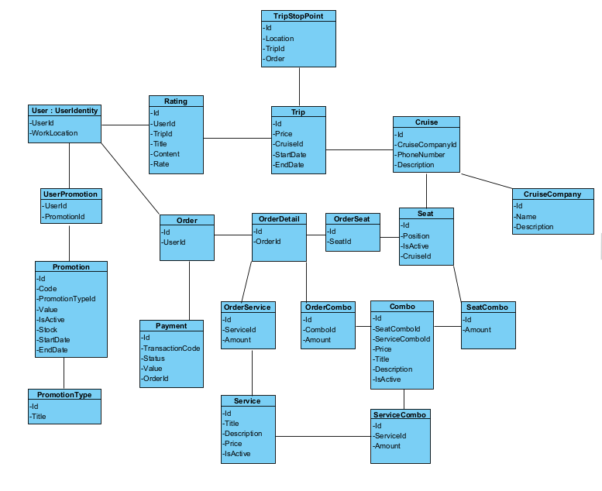

# 3.1.2 Detail of Entities

# 3.1.3 ERD 🡪 Database schema

# 3.2 Tables in your database

# - Number of tables:

# - Any tables:

# Example

| Products |  | Primary Key | Identity |
| --- | --- | --- | --- |
| Id | int | Yes | Yes |
| ProductName | nvarchar |  |  |

# 3.3 Relationship between the tables…

# Chụp ảnh Relationship diagram:

# Sau đó giải thích

# Sau khi mô tả:

# Bảng 1 liên kết với bảng 2 qua khoá ngoại…

# ….

# Chụp ảnh:

# 3.4 Connection database

# Data- first or code - first

# ConnectionString….

# Command….

# IV. Main Functions of Application

# 4.1 CRUD:

# - Member management:

# - Product management:

# - Order management:

# 4.2 Other functions: search, sort, export report (Excel, form…)….

* Register
* Login

# 4.3 Design API

# 

# 4.4 Implement (Coding)

**TEST CASE**

**Number of test cases:**

**Test functions…**

**TEST CASE RESULTS**

**Test functions…+ results**

**REFERENCE MATERIALS**

**[1]**

**[2]**

**[3]**

**[4]**

**[5]**

**[6]**